|  |  |  |
| --- | --- | --- |
|  | EUROPEAN COMMISSION  DIRECTORATE-GENERAL  INFORMATICS  Infrastructure and Logistics Directorate  **Technical solutions and office systems** | Digit |

**e-TrustEx Web Access**

**Creating an ECAS account for new users**

Before getting access to e-TrustEx you need to create an ECAS account, ECAS being the authentication system of the European Commission. After obtaining your ECAS account you will need to provide some information to your local Party Administrator.

* Navigate to the e-TrustEx URL: <https://webgate.ec.europa.eu/e-trustex>
* You are directed to the ECAS login screen – click on the link "Not registered yet".

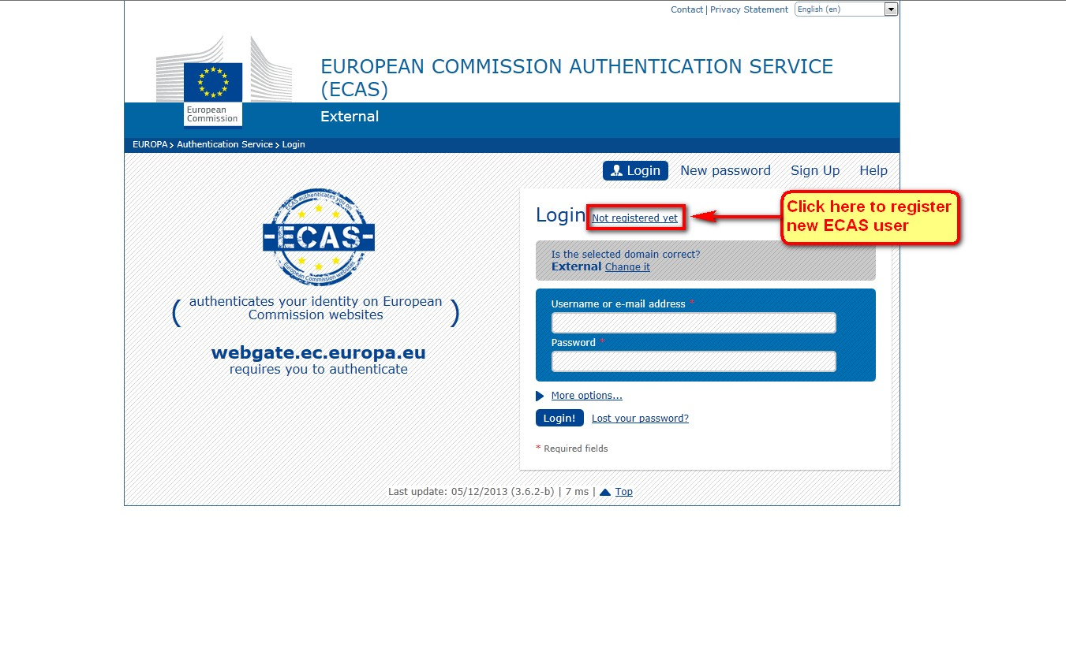

* On the new user registration screen enter your personal information. In this example we will create an ECAS user "etrustex-test-user". Enter your personal information and email address.
* Note – If you are a non EU institution you must select the "External" user type as shown in the screenshot below, otherwise select your EU institution type from the list.

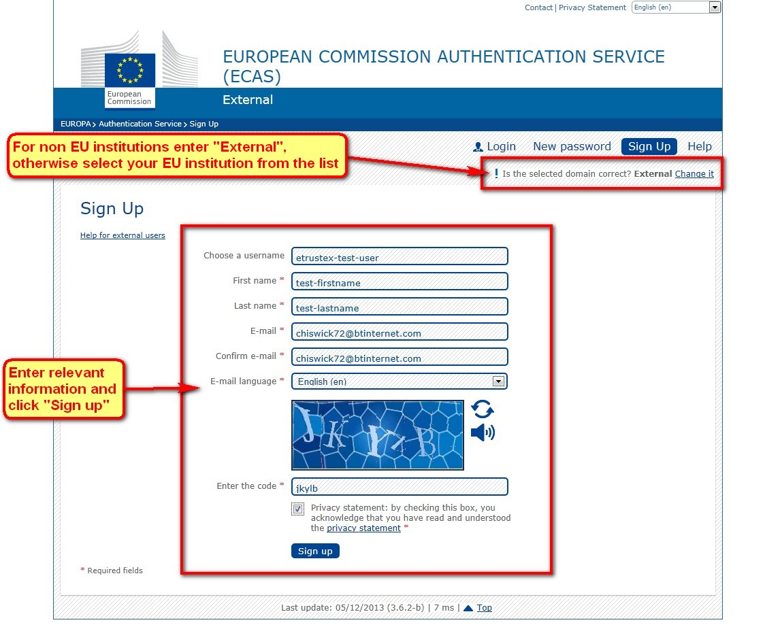

* After entering your personal information and submitting the application, you should see the following confirmation screen.

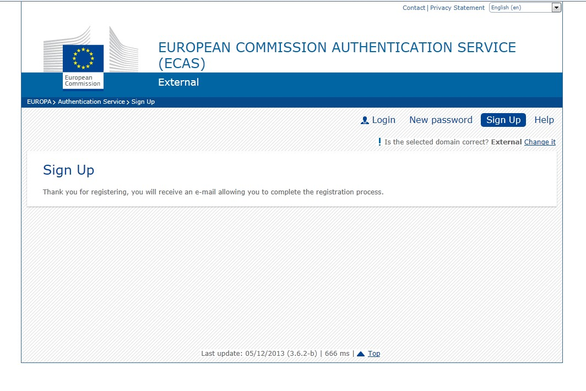

* Check your mail inbox for an ECAS confirmation email in order to complete the registration. In your inbox you should see an email like below – click on the link in the email to create a password for your account.

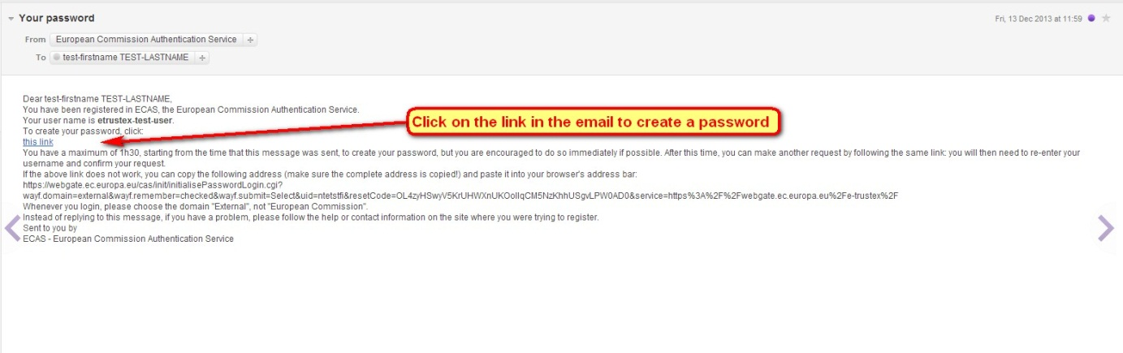

* The link directs you to the ECAS screen – enter a password and click "Submit".

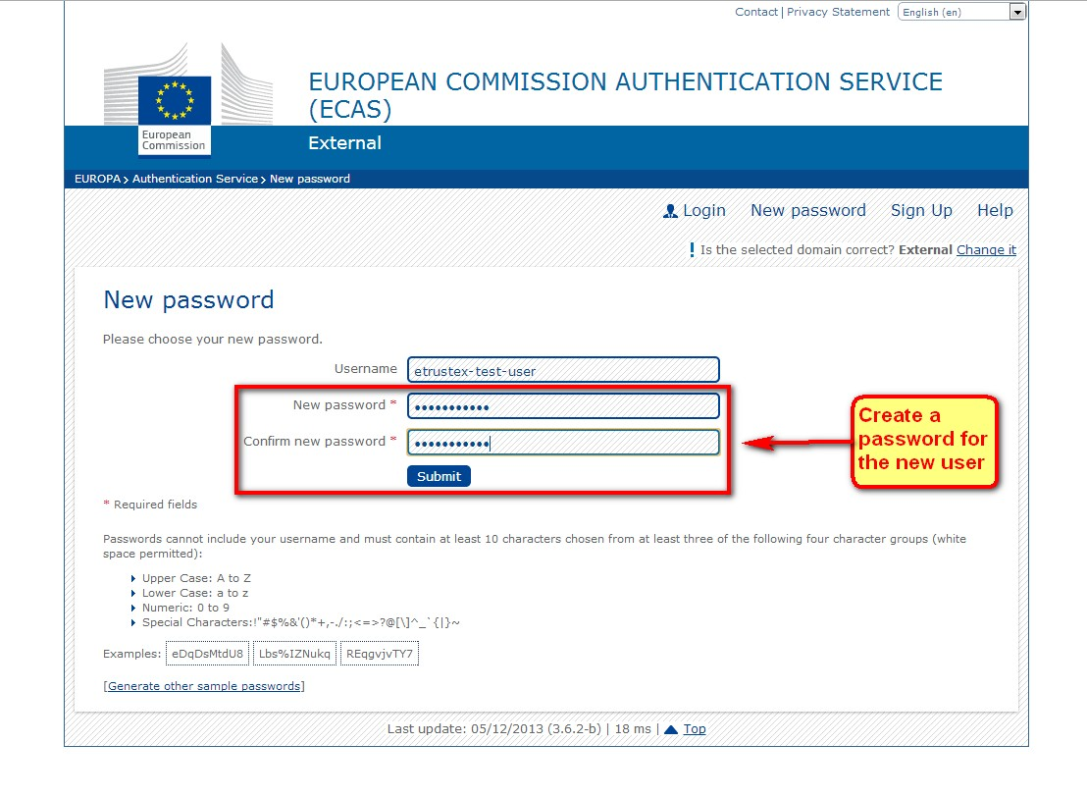

* After creating your password you are directed to the ECAS confirmation screen.
* On the confirmation screen click on the "Login" link as shown below.

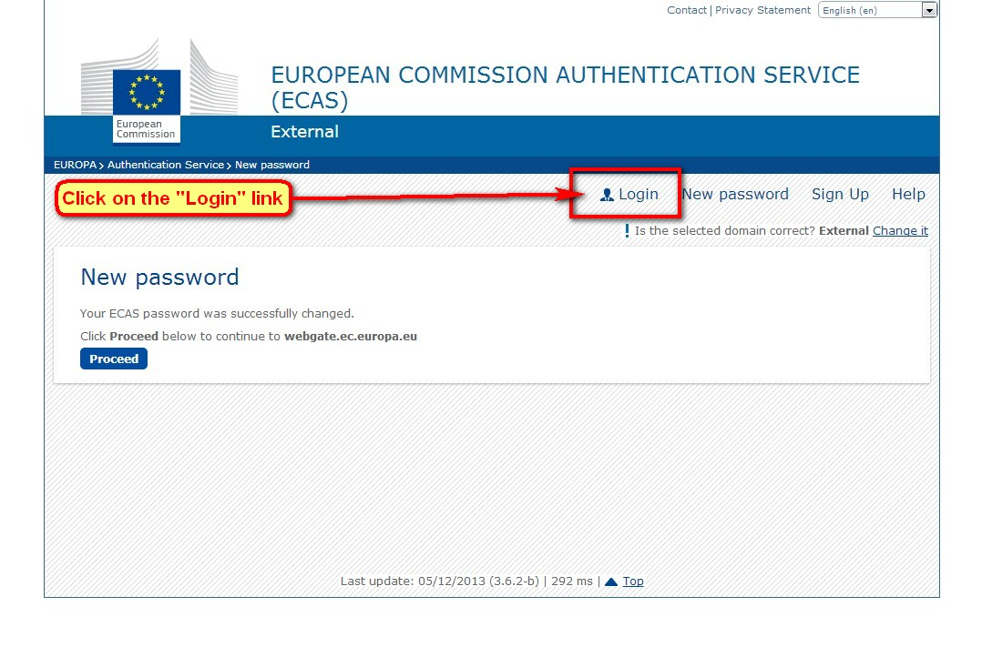

* You are directed to the ECAS login screen – enter the username and password created during the registration process and click on "Login".

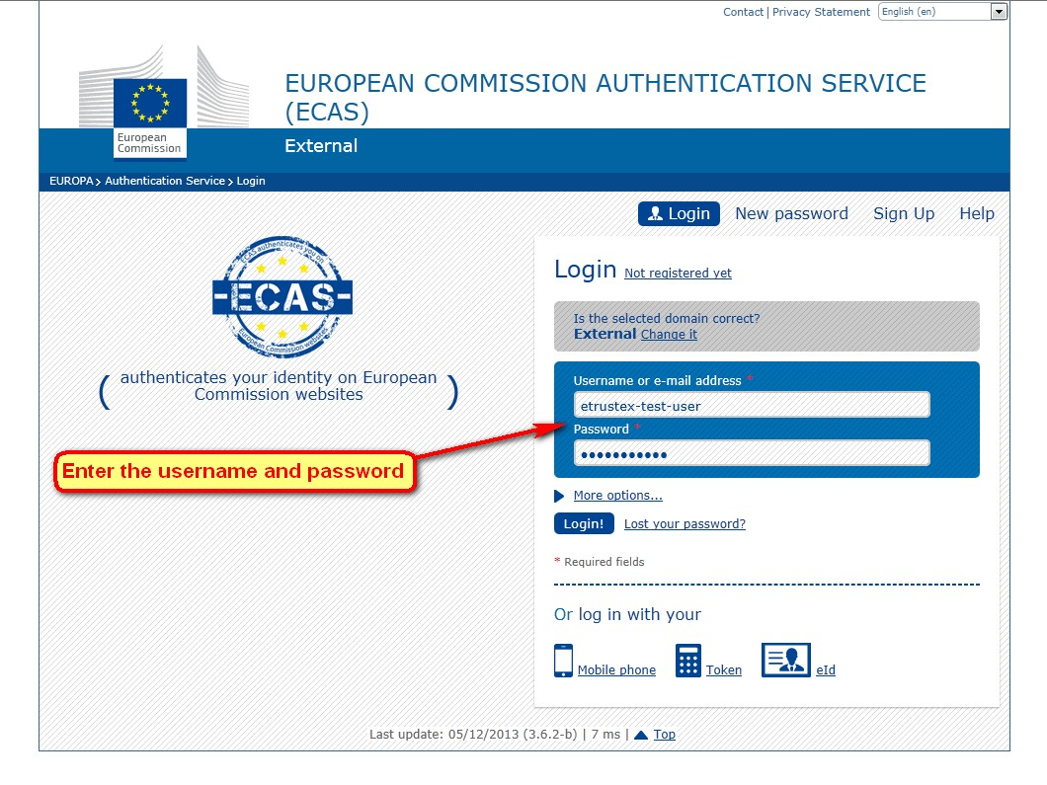

* After entering the correct username and password you will be logged into the ECAS system.
* Click on your username link on the screen as shown below – in our example the ECAS username is "etrustex-test-user".

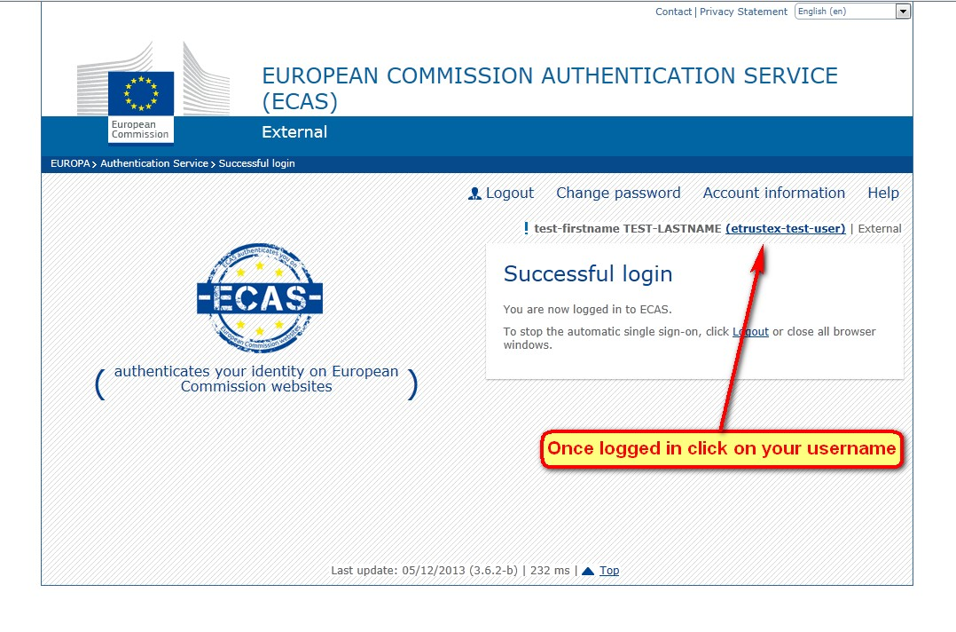

* You are redirected to the account details of your ECAS account.
* **Important** - Make a note of the "Unique identifier at the Commission (uid)" value – see the screenshot below – In our example the uid is "ntetstfi".
* Provide the uid to your e-TrustEx local Party Administrator with your full name, and optionally your email address, if you wish to receive an email notification when a new message arrives in the e-TrustEx Web application.
* Once you provide the information, your local Party Administrator will add your details to the e-TrustEx system.

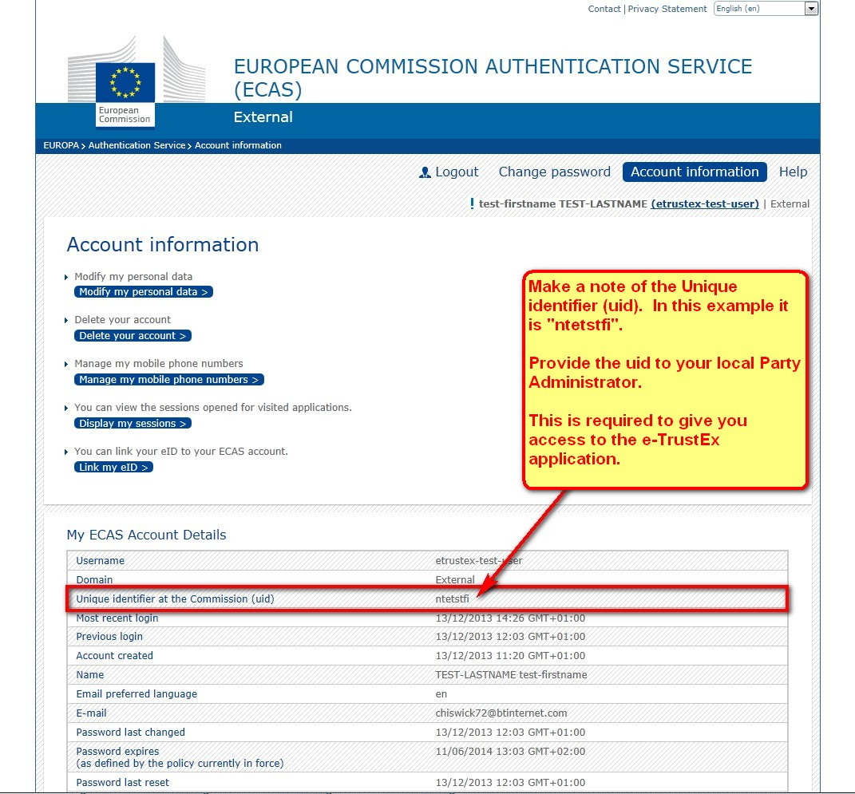

* Once the local Party Administrator adds your details to the system then you are ready to log onto the e-TrustEx application.
* Click on the URL below and enter your ECAS username and password and you will have access to your party on the e-TrustEx application via the link below:

e-TrustEx URL: <https://webgate.ec.europa.eu/e-trustex>